EMBEDDED SYSTEM AND DESIGN
EXPERIMENT NO. 5

PARKING LOT COUNTER

Name: Raphael S. Nano

Course/Section: CPE160P / B1

Date of Performance: September 11-14, 2023
Date of Submission: September 15, 2023

Ma'am Cyrel Manlises
Instructor

DISCUSSION

The number of vehicles in modern times increased drastically due to the evolution and development of technology. The need for containment and spaces for vehicles arose as their number increased. Parking lots and parking spaces became a necessity as people with personal and public vehicles go to various places and temporarily leave it there. Hence, for this experiment, a parking lot counter was constructed with the use of a servo motor, a stepper motor, two ultrasonic distance sensors, and a 4 digit 7-segment display to show the number of available and occupied slots.
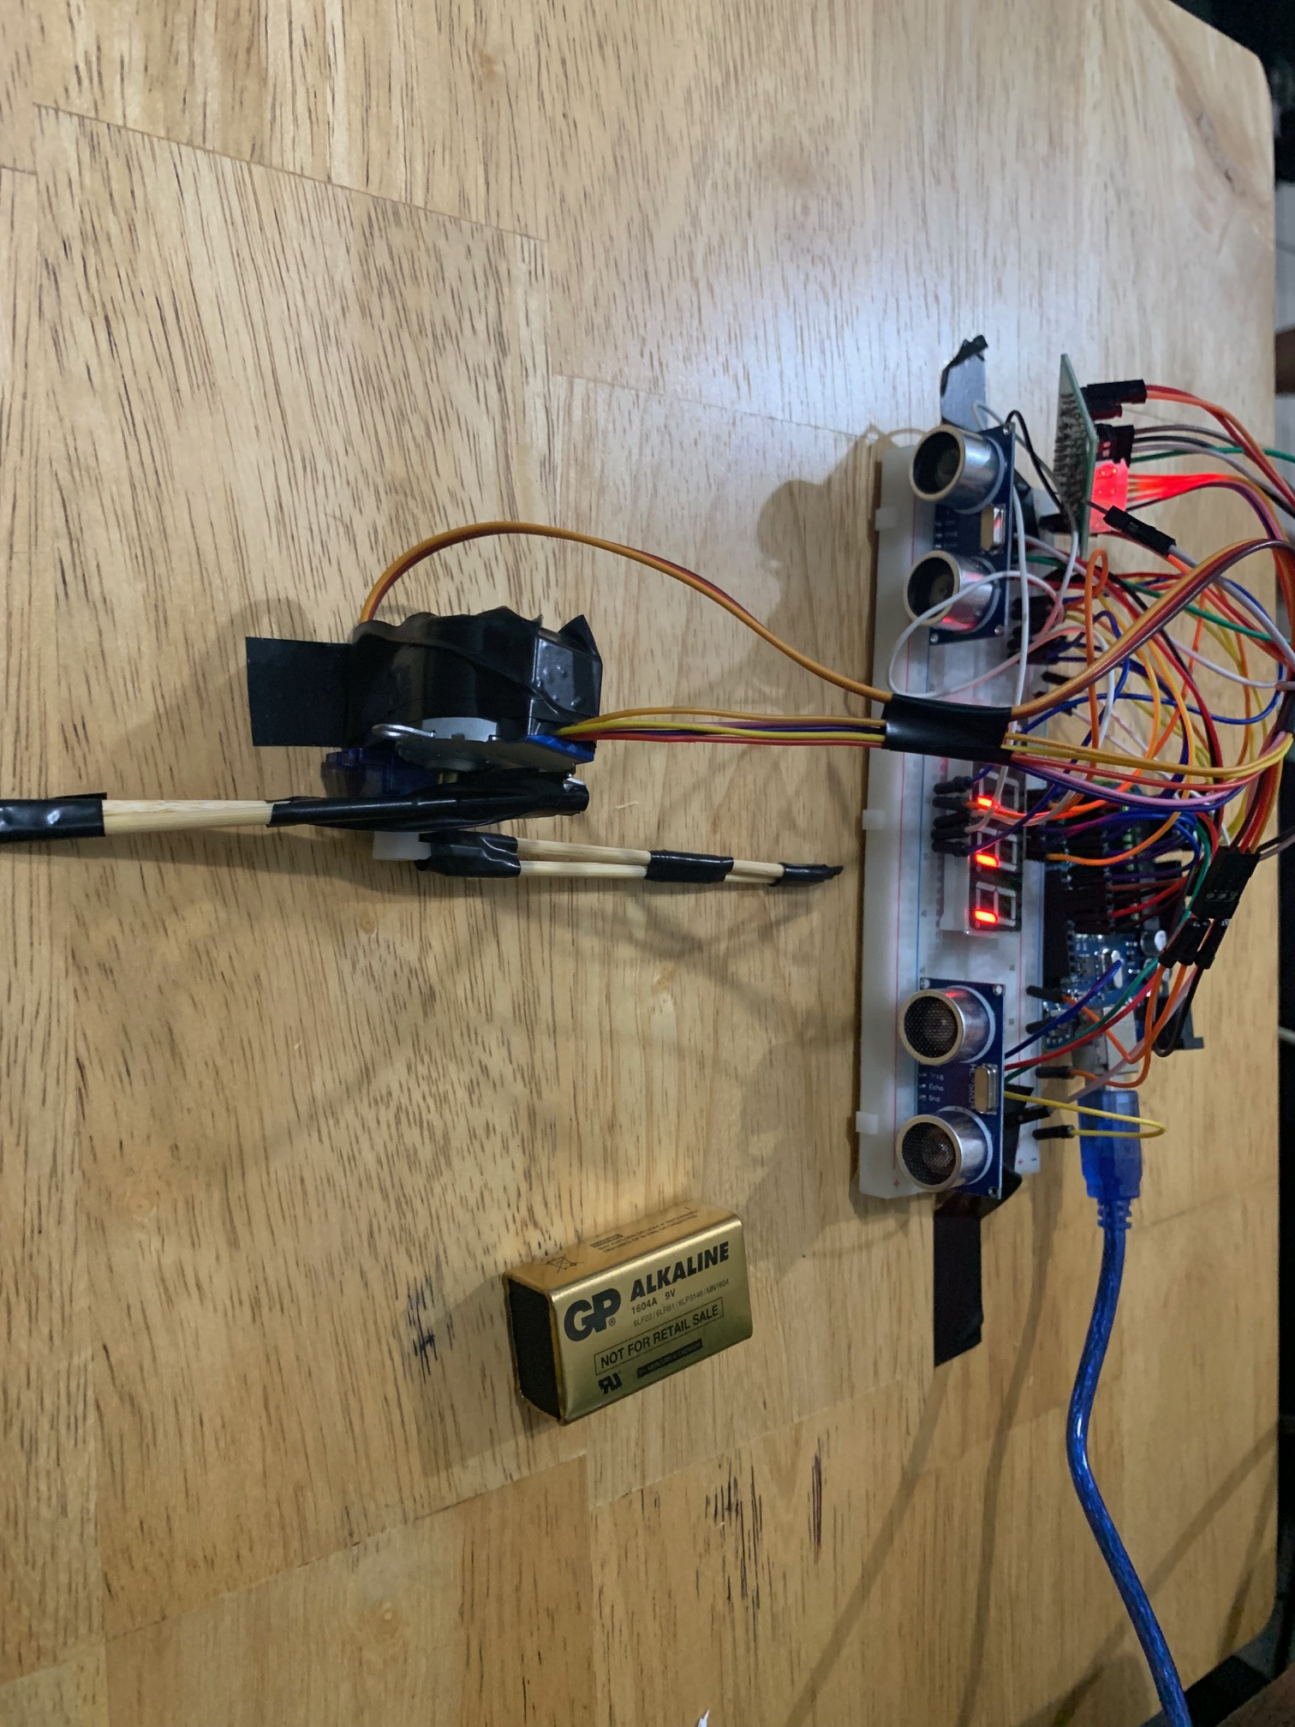

Figure 1. Circuit Setup for Experiment 5

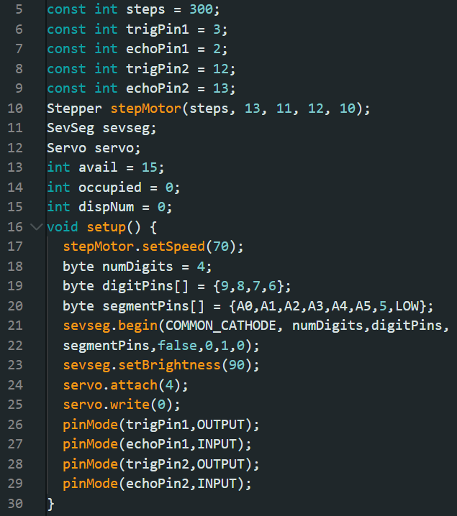

Figure 2. Code Setup for Experiment 5

The materials used to construct the parking lot counter, which are shown in Figure 1, are the Arduino UNO, an SG90 Servo motor, a 28BYJ-48 stepper motor, a motor driver module, two HC-sr04 ultrasonic distance sensors, and a 4-digit seven-segment display. The motors and the display all utilized an external library, namely Servo.h, Stepper.h, and SevSeg.h.
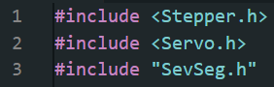

Figure 3. Inclusion of Libraries
The experiment primarily aims to demonstrate the system of a parking lot counter. For the process of the system, there should be two pathways: the entrance and the exit. These pathways should be connected within a single toll-gate. Inevitably, the component that determines the entering and exiting of a car is the ultrasonic distance sensor. By gauging the distance between the sensor and the possible car with respect to the driveway, the programmed motors will move if the cars were detected within the critical distance. The distances were also computed by using the formula Distance = (Speed*Time)/2, where speed is the sound's speed and time it reaches the object. Specifically, the entering pathway uses 14 as the value of the distance while the exiting path uses 10 as the distance. As shown in Figure 2, the function distance1() is for the computation of the distance of the sensor for the entrance, and distance2() is for the exit.

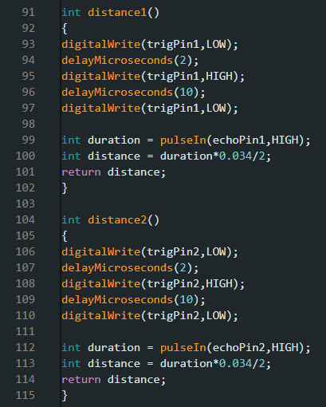

Figure 3. distance1() and distance2() functions

Moreover, the motors should go up every time the sensor detects an object. The stepper motor simply rotates clockwise for the object to go up, which is shown in the stepUp() function, else counter clockwise to go down, the stepDown(). The servo motor goes to 180 degrees to go up, which is the motorUp() function, and back to 0 to go down, the motorDown(). Moreover, sticks were connected to the ends of the motor so as to imitate a barrier in a toll-gate.

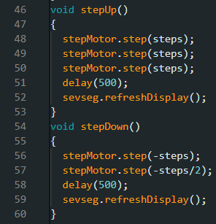

Figure 4. stepUp() and stepDown() functions
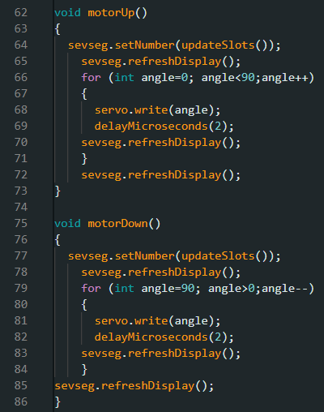

Figure 5. motorUp() and motorDown() functions

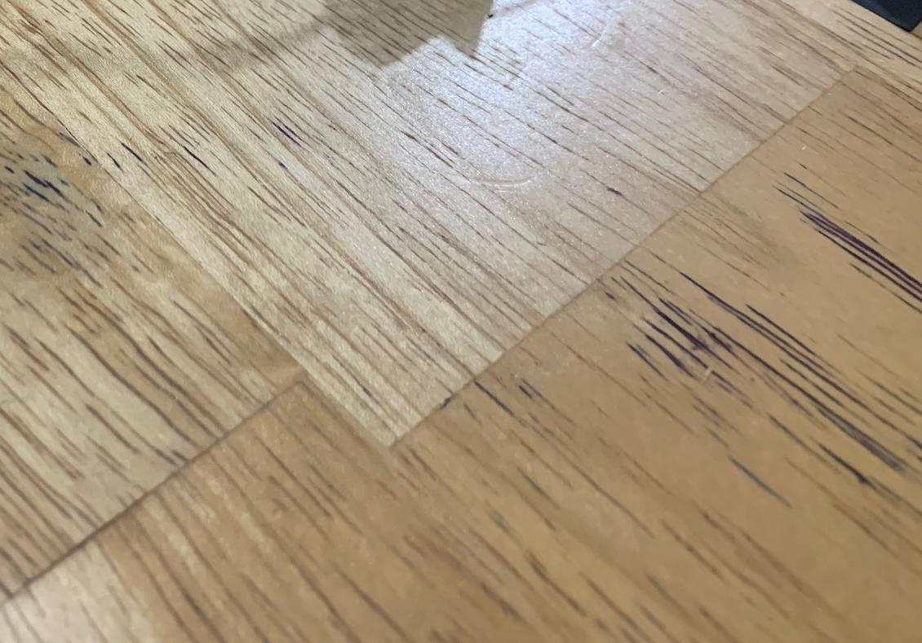

Figure 6. Stepper Motor and Servo Motor Gates
Lastly, the number of slots should be updated as well, depending on the status of cars. The first two digits of the seven-segment display are the occupied slots, while the last two digits are the available slots.
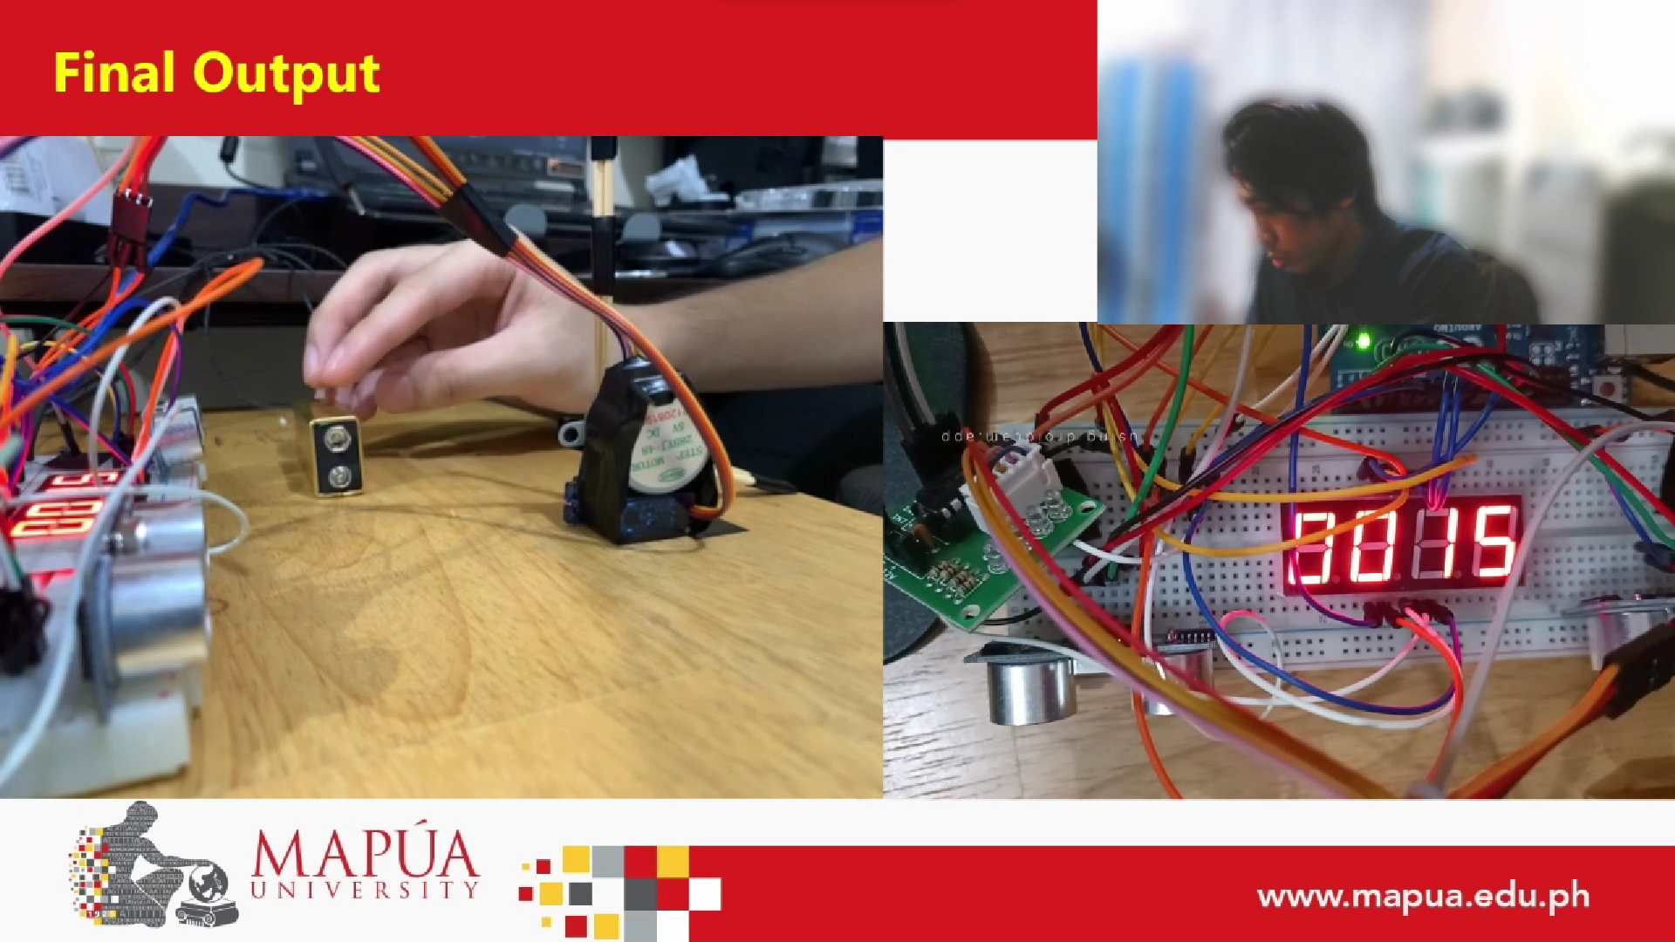

Figure 7.1. Zero (0) occupied slots, Fifteen (15) available slots

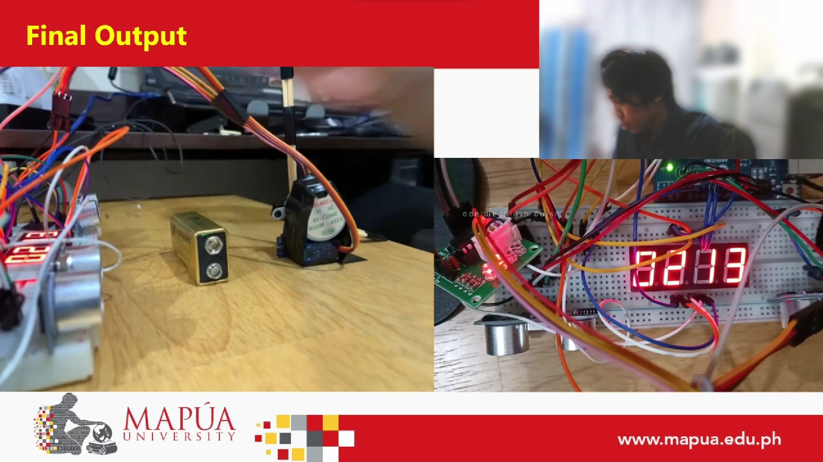

Figure 7.2. Two (2) occupied slots, Thirteen (113) available slots
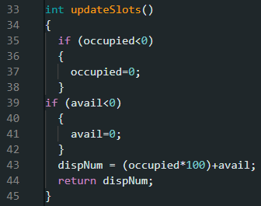
So, if a car enters, the occupied slots increase while the available slots decrease. On the other hand, if a car exits, the occupied slots decrease while the available slots increase. By using a universal variable, the occupied and the available, for the slots, the manipulation of the values became easier.

Figure 8. updateSlots() function

All of the functions mentioned above were combined together in the main loop, but it is again divided into two: a while loop for the entrance ultrasonic distance sensor and a while loop for the exit. The program first checks if the slots are full, and if it is, the program simply continues until the slots are updated by the updateSlots() function when a car has either exited or entered.
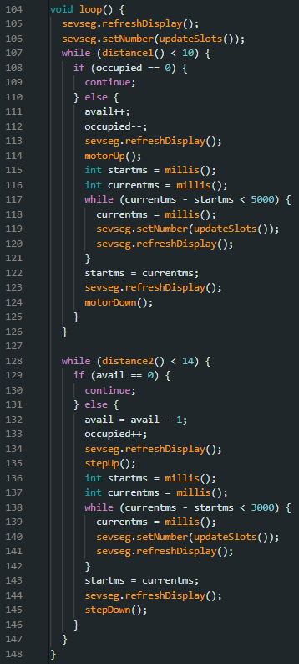
Figure 9.2. Main loop for ultrasonic distance sensor for exit
Figure 9.1. Main loop for ultrasonic distance sensor for entrance
CONCLUSION
In conclusion, for the first objective, the parking lot counter successfully works wherein if a car enters, the number of occupied slots increase and the number of the available slots decrease in the seven-segment display, and the stepper motor raises the gate, and if a car exits the occupied slots decrease, the available slots increase, and the servo motor raises the gate. For the second objective, as the ultrasonic distance sensors sense an object within critical distance, the value of the count is being updated and checks how many entered and exited as aforementioned. Simultaneously, the motors rotate to raise the gate after sensing an object, which achieves the third objective. The series connections, pin configurations, and triggering of sensors prove the application of microprocessors, logic circuits, and switching theory. Hence, with the use of various variables, functions, and calling of such functions to develop an embedded system, the parking lot counter, in a simple handshaking.

